**SPECULATIONS ON ARTIFICIAL GENERAL INTELLIGENCE**

**Understanding ANI and AGI**

* **ANI refers to AI systems designed to perform specific tasks exceptionally well, such as smart speakers and self-driving cars, and has seen significant advancements in recent years.**
* **AGI, on the other hand, aims to create AI systems that can perform any intellectual task a human can do, but progress towards AGI remains uncertain and complex.**

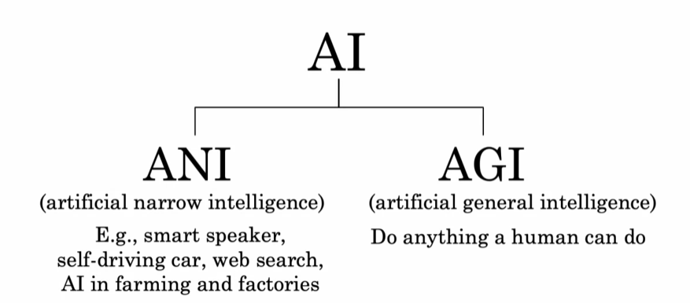

**Challenges in Simulating the Human Brain**

* **Current artificial neural networks are much simpler than biological neurons, making it difficult to accurately model human brain functions.**
* **Our limited understanding of how the human brain operates poses a significant challenge in simulating it for AGI development.**

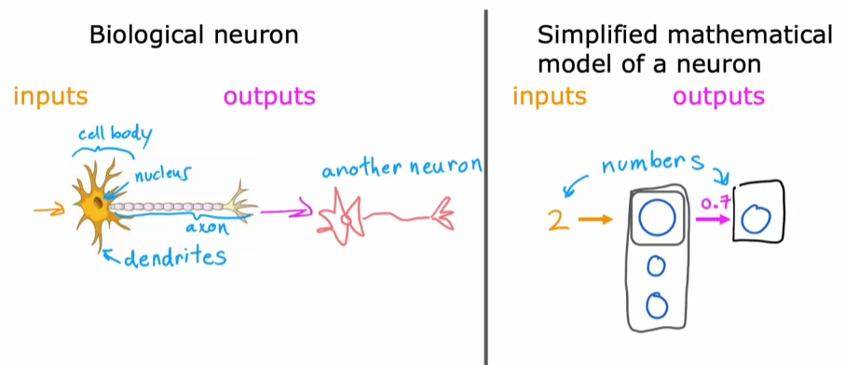

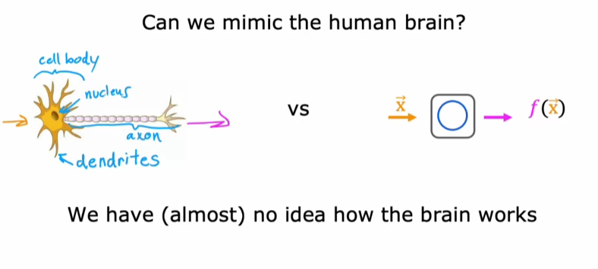

**Hope for Future Breakthroughs**

* **Experiments suggest that the same brain tissue can adapt to perform various tasks, hinting at the possibility of a few core learning algorithms that could be replicated in AI systems.**
* **Despite the challenges, the adaptability of the human brain keeps the hope for breakthroughs in AGI alive, encouraging ongoing research and exploration in this fascinating field.**

